##def add_five(x):

## temp=x+5

## return temp

##

##nums=[11,22,33,44,55]

##result=list(map(add_five,nums))

##print(nums)

##print(result)

##

##print('-'*40)

##num=[11,22,33,44,55]

##result=list(map(lambda x:x+5,num))

##print(num)

##print("After use of lambda in map:",result)

##

##def cube(a):

## return a*a*a

##lst=[0,1,2,3,4,5,6,7]

##res=list(map(cube,lst))

##print(res)

lst=[0,1,2,3,4,5,6,7]

res1=list(map(lambda x:x*x*x,lst))

print("After use of lamda in map:",res1)

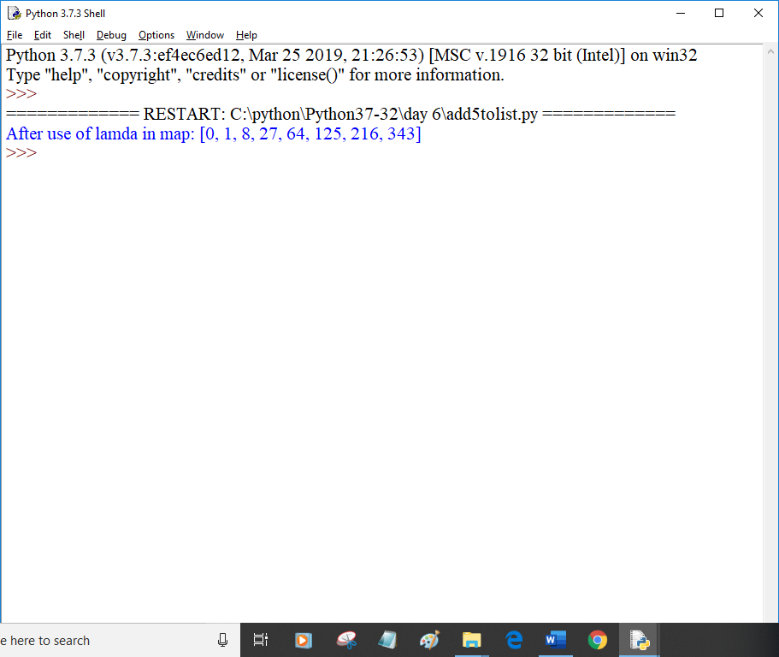

x=[2,3,4,5]

y=[-1,2,-2,1]

print("x:",x)

print("y:",y)

res=[]

for i,j in zip(x,y):

res.append(i+j)

print("res:",res)

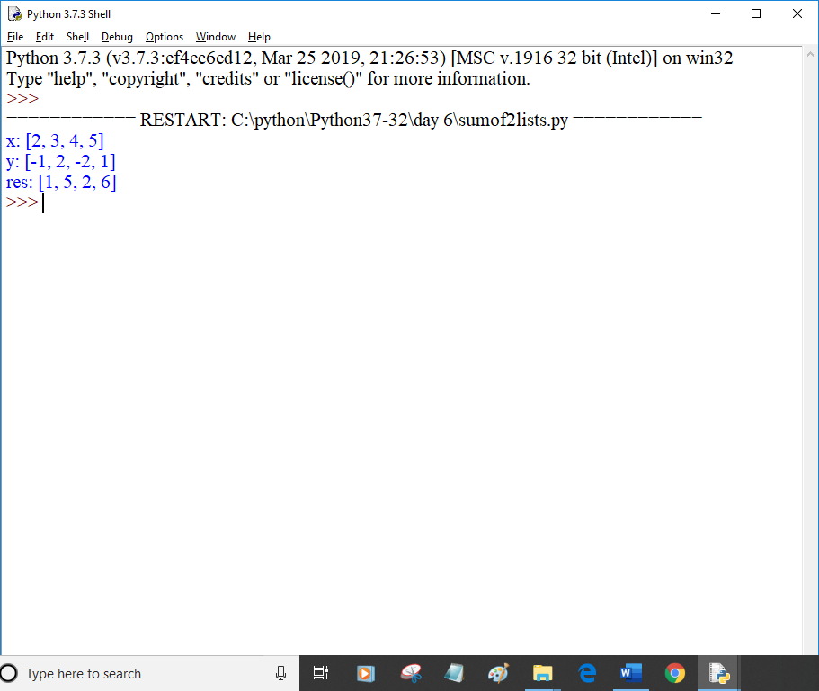

x=[2,3,4,5]

y=[-1,2,-2,1]

z=[10,20,15,30,25,67]

print("x:",x)

print("y:",y)

print("z:",z)

res=[]

for i,j,k in zip(x,y,z):

res.append(i+j+k)

print("res:",res)

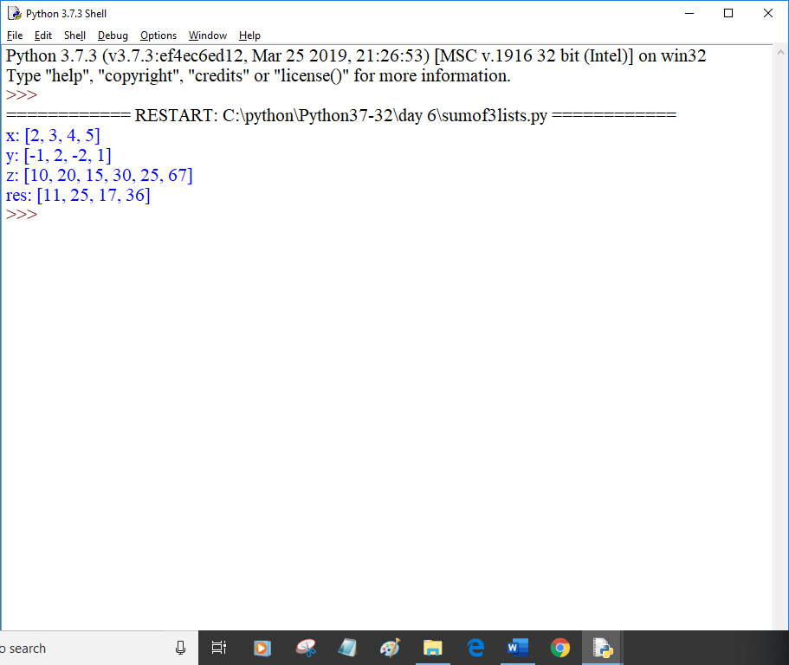

##x=[1,2,3,4,5,6]

##y=[10,20,30,40,50,60]

##z=[11,22,33,44,55,66]

##res=list(map(lambda a,b,c:a+b+c,x,y,z))

##print(res)

def add(a,b,c):

return a+b+c

x=[1,2,3,4,5,6]

y=[10,20,30,40,50,60]

z=[11,22,33,44,55,66]

res=list(map(add,x,y,z))

print(res)

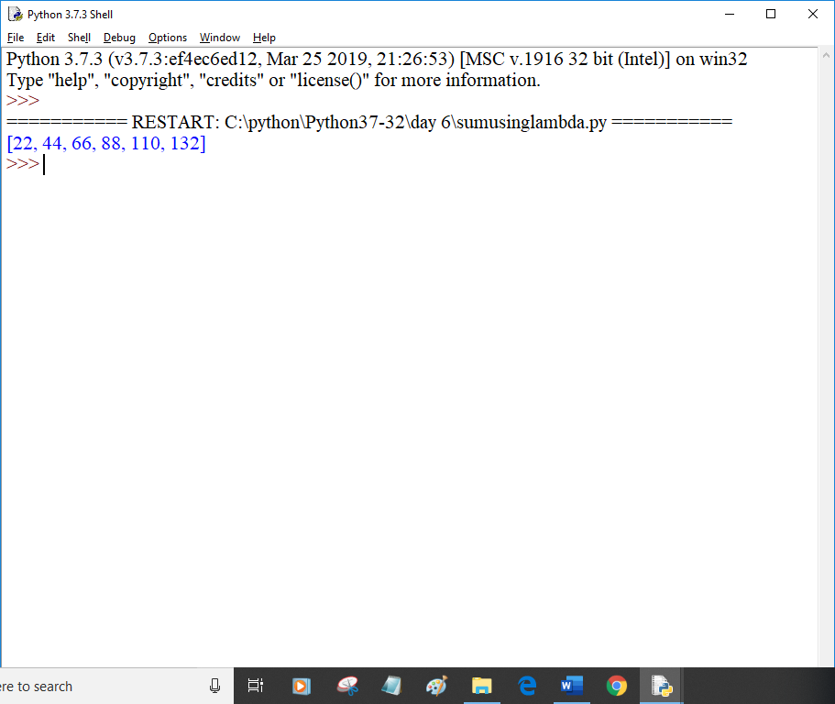

x=[11,8,5,21,9,11,5,11,6,9,21,8,7]

print(x)

y=[]

for i in x:

if i not in y:

y.append(i)

print(y)

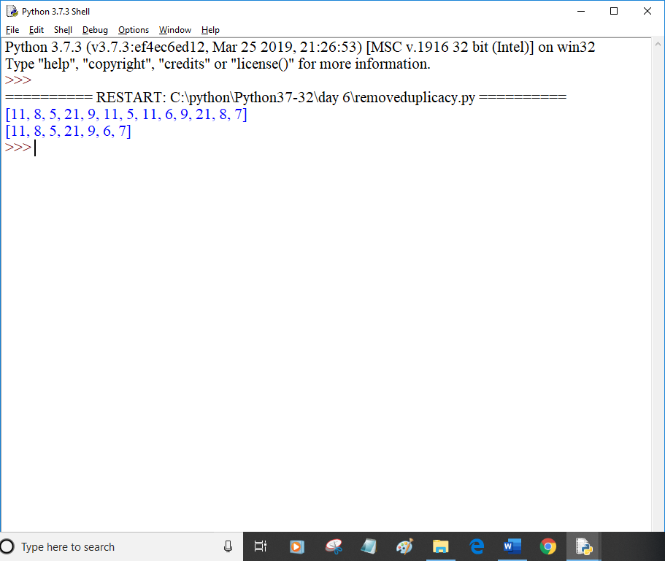

lst = [11,8,5,21,9,11,5,11,9,21,8]

print(lst)

new_set=set(lst)

lst=list(new_set)

print(lst)

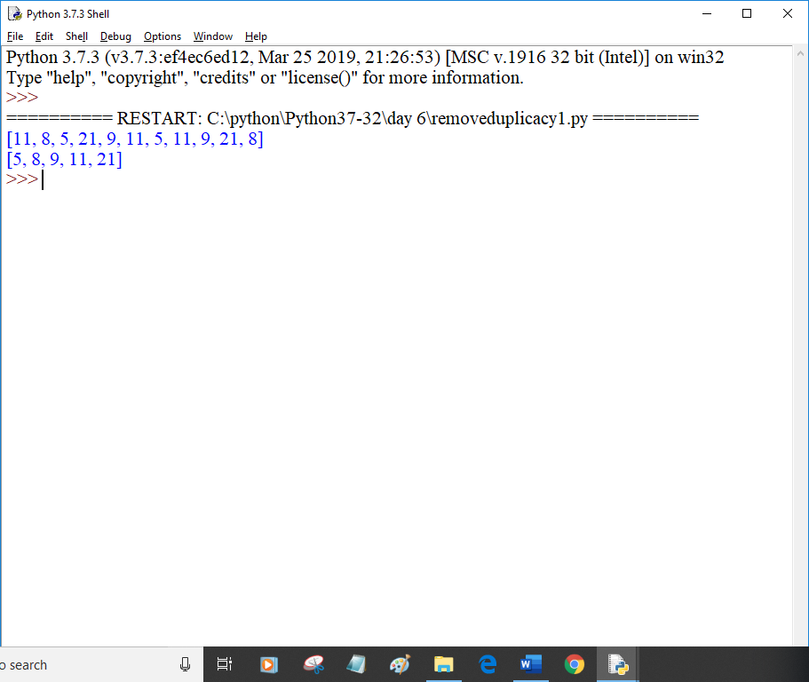

lst=['apple','mango','papaya','orange']

res_lst=list(map(len,lst))

print(res_lst)

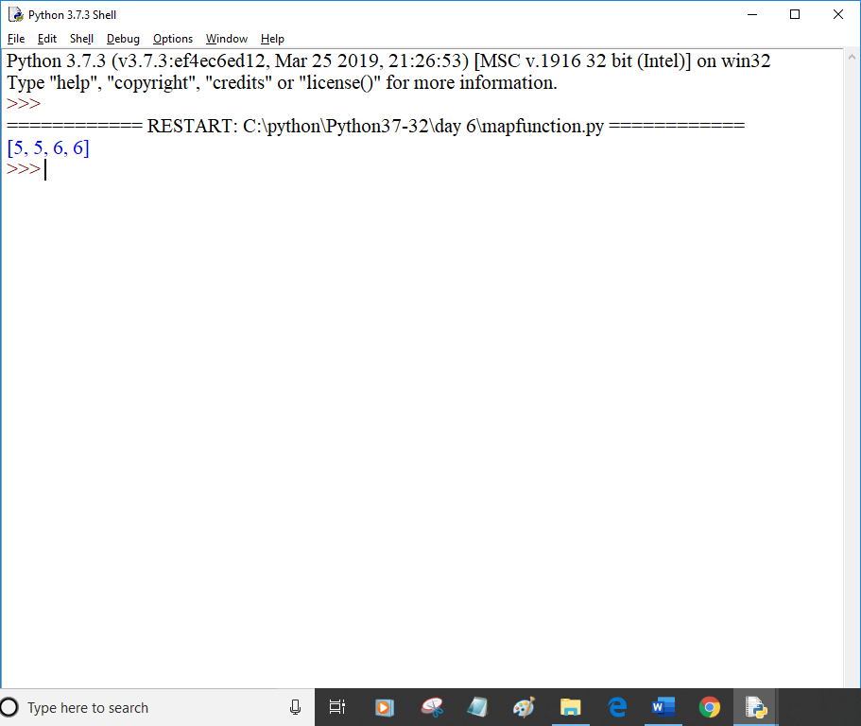

##def find_odd(x):

## if x%2==1:

## return True

## else:

## return False

##def find_even(x):

## if x%2==0:

## return True

## else:

## return False

##

##nums=[11,22,33,44,55]

##result=list(filter(find_odd,nums))

##print(nums)

##print('odd:',result)

##print('-'*20)

##result=list(filter(find_even,nums))

##print('even:',result)

##nums=[11,22,33,44,55]

##result=list(filter(lambda x:x%2==1,nums))

##print(nums)

##print('odd:',result)

##print('-'*20)

##result=list(filter(lambda x:x%2==0,nums))

##print('even:',result)

##x=['python','java',88,99,11,'c++','pearl','ada']

##def fun_str(a):

## if isinstance(a,str):

## return a

##y=list(filter(fun_str,x))

##print(y)

x=['python','java',88,99,33.7,11,'c++','pearl','ada']

def fun_str(a):

if isinstance(a,str):

return a

y=list(filter(fun_str,x))

z=list(filter(lambda a:isinstance(a,int),x))

p=list(filter(lambda a:isinstance(a,(int,float)),x))

print(y)

print(z)

print(p)

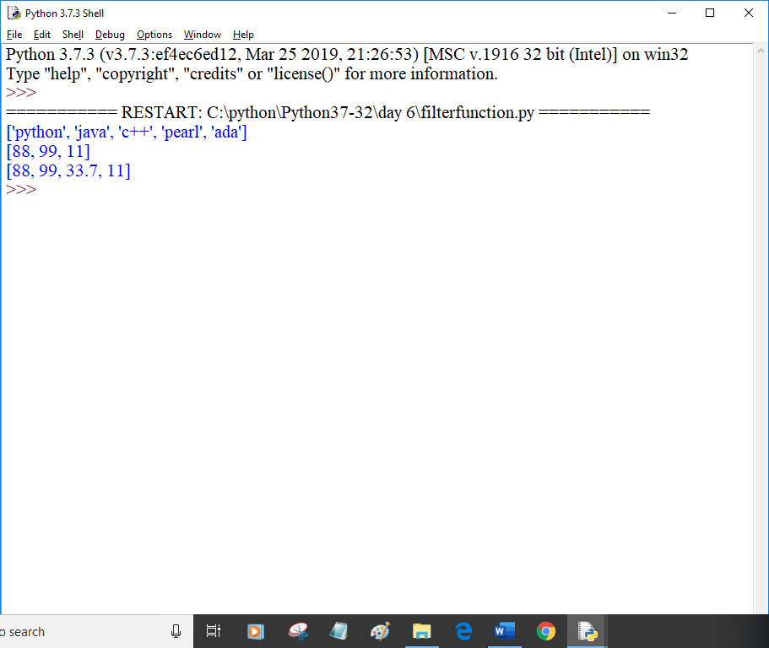

items = ['egg','milk','butter','peanuts','oats','honey']

for i in enumerate(items):

print(i,end=',')#tuples with index and element of iterator.

print('\n')

items = ['cup','pen','book']

for i in enumerate(items,100):

print(i,end=',')

